DREILEBEN
16.5MM HO
Dreileben is a small HO scale layout based on a fictitious location in Sachsen-Anhalt in the former East Germany. It is set in the late 1980s shortly before the demise of the DDR and the German reunification.
It portrays the end of a rural branch line and portrays short freight and passenger trains typical of the era and region. The layout is dominated by a 2 large structures – a factory in the background which isn’t rail served and a grain silo which is rail served.
The trackplan is based on a classic design which has been used many times in different guises. It was originally devised by the late Jack Trollope (“Shortliner” on many social media platforms).
A mixture of steam and diesel traction is used, all locos and stock from the major European manufacturers, especially Roco and Piko.
The layout is operated by DCC but the turnouts are hand thrown for simplicity.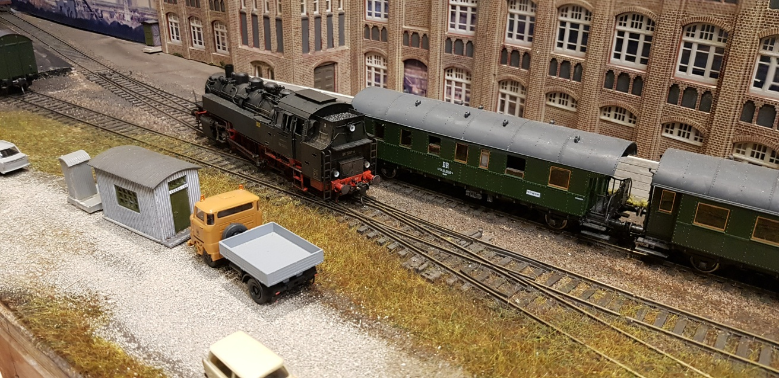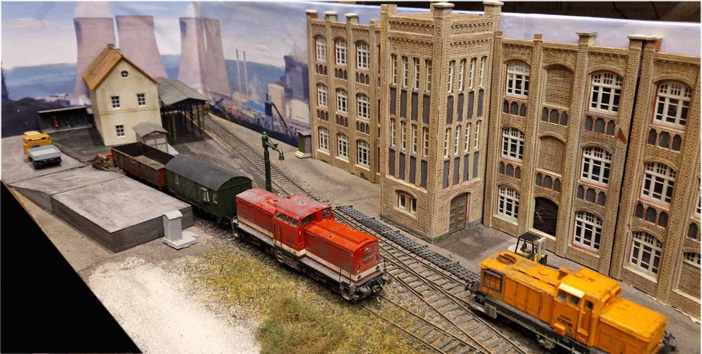
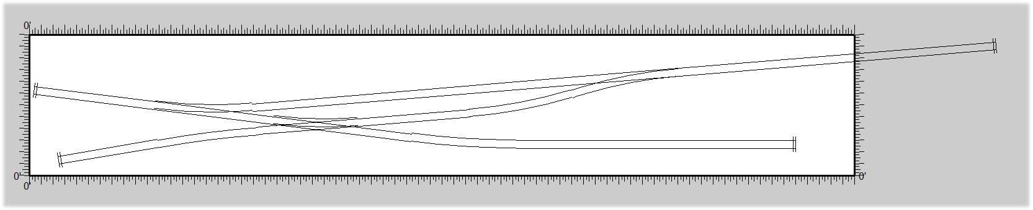
FRONT - OPERATION AND VIEWING FIDDLE YARD

Contact details:
Nick Palette
n.palette@ntlworld.com
07850 017222
Exhibition:
2/3 operators.
Based in South Staffordshire
Transported in own vehicles – expenses fuel and overnight where appropriate.

